1. *Nagios is one of the most widely used open source monitoring tool for monitoring the services and application that run's on Windows and Linux. It also has the capability to monitor routers and other network devices.*
2. *Nagios Core is a free and open source tool that allows you to monitor your entire IT infrastructure to ensure hosts, services and applications are functioning properly.*
3. *The article is intended for use by Nagios Administrators who wish to monitor Linux servers with Nagios Core using the linux NRPE agent.*

*192.168.72.80 a.deep.com (Ubuntu-Server)*

*192.168.72.81 b.deep.com (Ubuntu -Client)*

*192.168.72.82 c.deep.com(Centos-Client)*

***Before compiling the Nagios from the source, you would need to install dependent packages for Nagios.***

*apt-get update*

*apt-get install build-essential apache2 php openssl perl make php-gd libgd-dev libapache2-mod-php libperl-dev libssl-dev daemon wget apache2-utils unzip -y*

***Now add nagios user and nagcmd group.***

*useradd nagios*

*groupadd nagcmd*

*usermod -aG nagcmd nagios*

*usermod -aG nagcmd www-data*

***Now use below commands to download Nagios core.***

*wget https://assets.nagios.com/downloads/nagioscore/releases/nagios-4.4.3.tar.gz*

*tar -zxvf nagios-4.4.3.tar.gz*

*cd nagios-4.4.3/*

*./configure --with-ngios-group=nagios --with-command-group=nagcmd --with-httpd_conf=/etc/apache2/sites-enabled/*

*make all*

*make install*

*make install-init*

*make install-config*

*make install-commandmode*

***Execute the below command in the terminal to install Nagios web interface.***

*make install-webconf*

***Now Edit the /usr/local/nagios/etc/objects/contacts.cfg file and change the email address associated with the nagiosadmin contact definition to the address.***

*vi /usr/local/nagios/etc/objects/contacts.cfg*

**

***Now Create a user account (nagiosadmin) for logging into the Nagios web interface.***

*htpasswd -c /usr/local/nagios/etc/htpasswd.users nagiosadmin*

***Then Run the below command.***

*a2enmod cgi*

*systemctl restart apache2*

***Now Install Nagios Plugins***

*wget https://nagios-plugins.org/download/nagios-plugins-2.2.1.tar.gz*

*tar -zxvf nagios-plugins-2.2.1.tar.gz*

*cd nagios-plugins-2.2.1/*

*./configure --with-nagios-user=nagios --with-nagios-group=nagios*

*make*

*make install*

***Verify the sample Nagios configuration files and start.***

### */usr/local/nagios/bin/nagios -v /usr/local/nagios/etc/nagios.cfg*

*systemctl start nagios*

*systemctl enable nagios*

***Now Access Nagios***

*http://192.168.72.80/nagios/*

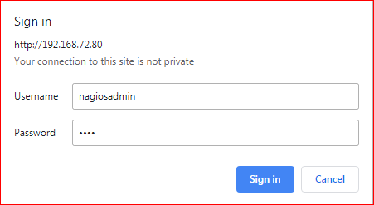

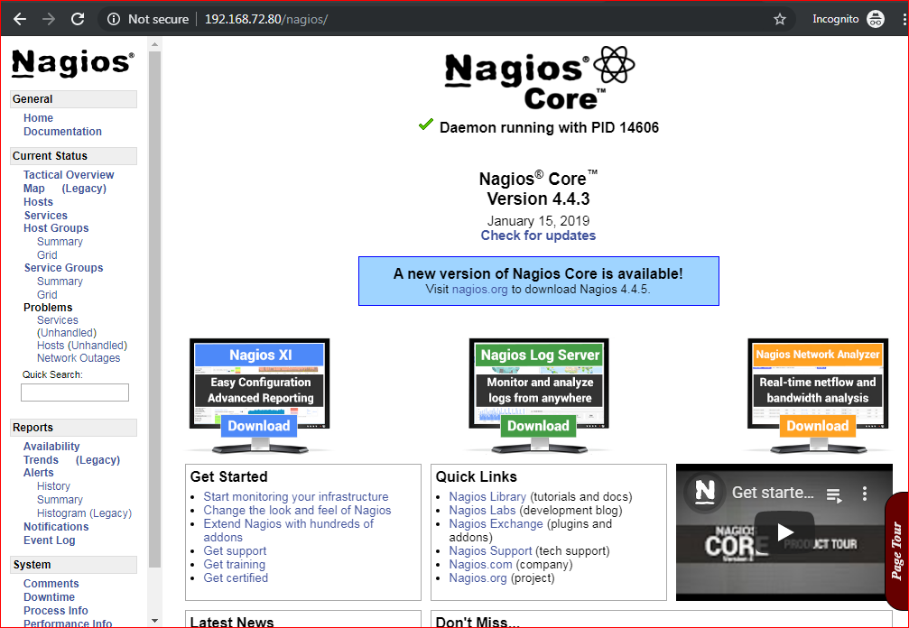

***Now Configure NRPE On The Remote Machine***

***NRPE(*** Nagios Remote Plugin Executor ***) Plugin***

*NRPE plugin allows you to monitor applications and services running on remote Linux / Windows hosts. This NRPE Add-on helps Nagios to monitor local resources like CPU, Memory, Disk, Swap, etc. of the remote host.*

***At Centos***

*yum install -y epel-release*

*rpm -ivh https://dl.fedoraproject.org/pub/epel/epel-release-latest-7.noarch.rpm*

*yum install -y nrpe nagios-plugins-all*

***At Ubuntu***

*apt-get update*

*apt-get install nagios-nrpe-server*

*apt-get install nagios-plugins-basic nagios-plugins nagios-plugins-extra*

***Now Edit the file.***

*vi /etc/nagios/nrpe.cfg*

## 

***Add these lines at bottom of the file***

***For CentOS***

*command[check_users]=/usr/lib64/nagios/plugins/check_users -w 5 -c 10command[check_load]=/usr/lib64/nagios/plugins/check_load -w 15,10,5 -c 30,25,20command[check_root]=/usr/lib64/nagios/plugins/check_disk -w 20% -c 10% -p /dev/mapper/centos-root*

*command[check_swap]=/usr/lib64/nagios/plugins/check_swap -w 20% -c 10%command[check_total_procs]=/usr/lib64/nagios/plugins/check_procs -w 150 -c 200*

***For Ubuntu***

*command[check_users]=/usr/lib/nagios/plugins/check_users -w 5 -c 10command[check_load]=/usr/lib/nagios/plugins/check_load -w 15,10,5 -c 30,25,20*

*command[check_root]=/usr/lib/nagios/plugins/check_disk -w 20% -c 10% -p /dev/mapper/server--vg-root*

*command[check_swap]=/usr/lib/nagios/plugins/check_swap -w 20% -c 10%*

*command[check_total_procs]=/usr/lib/nagios/plugins/check_procs -w 150 -c 200*

***-w stands for warning***

***-c stands for critical.***

*Now Restart the NRPE service.*

***For CentOS***

*systemctl start nrpe*

*systemctl enable nrpe*

***For Ubuntu***

*systemctl restart nagios-nrpe-server*

***At Nagios Server***

***Install the check_nrpe plugin.***

*apt-get install nagios-nrpe-plugin -y*

***Edit the Nagios configuration file to include all .cfg files inside the /usr/local/nagios/etc/servers directory.***

*vi /usr/local/nagios/etc/nagios.cfg*

*U****ncomment the line no. 51.***

*cfg_dir=/usr/local/nagios/etc/servers*

***Now Create a directory.***

*mkdir /usr/local/nagios/etc/servers*

***Now configure Nagios server to monitor the remote client machine, and You’ll need to create a command definition in Nagios object configuration file to use the check_nrpe plugin.***

*vi /usr/local/nagios/etc/objects/commands.cfg*

***Add the following Nagios command definition to the file.***

*# .check_nrpe. command definition*

*define command{*

*command_name check_nrpe*

*command_line /usr/lib/nagios/plugins/check_nrpe -H $HOSTADDRESS$ -t 30 -c $ARG1$*

*}*

***Now Add a host to Nagios server***

***Create a client configuration file /usr/local/nagios/etc/servers/b.deep.com.cfg and c.deep.com.cfg to define the host and service definitions of remote host.***

*vi /usr/local/nagios/etc/servers/b.deep.com.cfg*

*define host{*

*use linux-server*

*host_name b.deep.com*

*alias b.deep.com*

*address 192.168.72.81*

*}*

*define hostgroup{*

*hostgroup_name linux-server -------------------------- for ubuntu replace it with ( b.deep.com ).*

*alias Linux Servers*

*members b.deep.com*

*}*

*define service{*

*use local-service*

*host_name b.deep.com*

*service_description SWAP Uasge*

*check_command check_nrpe!check_swap*

*}*

*define service{*

*use local-service*

*host_name b.deep.com*

*service_description Root / Partition*

*check_command check_nrpe!check_root*

*}*

*define service{*

*use local-service*

*host_name b.deep.com*

*service_description Current Users*

*check_command check_nrpe!check_users*

*}*

*define service{*

*use local-service*

*host_name b.deep.com*

*service_description Total Processes*

*check_command check_nrpe!check_total_procs*

*}*

*define service{*

*use local-service*

*host_name b.deep.com*

*service_description Current Load*

*check_command check_nrpe!check_load*

*}*

***Same process for c.deep.com***

*vi /usr/local/nagios/etc/servers/c.deep.com.cfg*

*put the same entry as ubuntu client*

***You can Verify Nagios for any errors.***

*/usr/local/nagios/bin/nagios -v /usr/local/nagios/etc/nagios.cfg*

*systemctl restart nagios*

*If you want monitor http , ftp, smtp, pop3 etc services the you have to add this line*

*define service{*

*use local-service*

*host_name b.deep.com*

*service_description Current Load*

*check_command check_http*

*}*